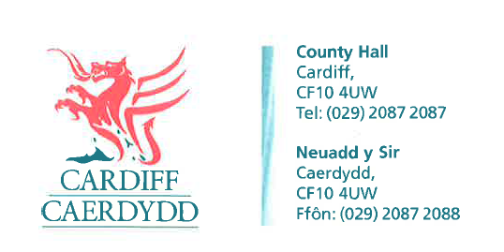
FOI Response Document
FOI16980
Thank you for your request under the Freedom of Information Act 2000 about 2 bed adapted houses received on 09/11/2021:
How many 2 bed adapted houses included any new build houses built have been allocated in Canton and Radyr since 2019?
We have considered your request and enclose the following information:
Response: The City of Cardiff Council can confirm that there have been 0 adapted houses allocated in Canton and Radyr since 2019.
There has been a total of 5 ‘easy access’ properties allocated since 2019. 1 in the Canton area and 4 in Morganstown.
If you have any queries or concerns, please do not hesitate to contact us.
Please remember to quote the reference number above in any future communications.

